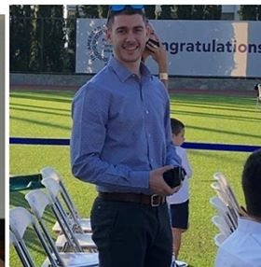 |  | yiangos karavis
Contact  PHONE:  +306976860777  EMAIL:  yiangos@karavis.gr  SOFT SKILLS  Leadership  Observational skills  Patient  Risk taker  Teamwork  Positive attitude  Hobbies  Basketball  Skiing  Scuba (3 certificates)  Fencing  Speedboat and sailboat diploma  languages  Greek(native)  Italian(native)  English (professional C2) (IELTS, ECPE)  Romanian(excellent)  French(basic) (DELF A1, DELF A2) |  | EDUCATION  Resident in Anesthesiology in Aretaieio Hospital  Augoust 2022-  Master in algology and pain management. EKPA University  February 2023  Carol Davila University of Medicine and Pharmacy (Facultatea de Medicină) Romania  2014-2020  Neurology 10/10  Rheumatology 8/10  Athletic scholarship (2018-2019)  Mc Daniel college-premed program  2013-2014  Admitted first in Semmelweis university of medicine.  Pierce-The American College of Greece  2009-2013  Graduated with 17.6/20  Member of basketball team  seminars - certificates  The “LifeSIM” Medical Simulation Center  29 February 2020  Basic clinical skills workshop  Kineto didactica  16-17 November 2019  Red flags, serious spinal pathology and thinking processes  The international medical students congress of Bucharest  6-10 December 2017  Advanced life support workshop (ALS)  Infectious diseases workshop  Neuroscience Optional Course  2015-2016 academic year  Presented: Neuroplasticity of the brain  Summer practice at Filoktitis medical rehabilitation center  1-21 august 2016  Patient monitoring, history taking.  Romanian Red cross.  November 2015  First aid responder( basic life support course)

